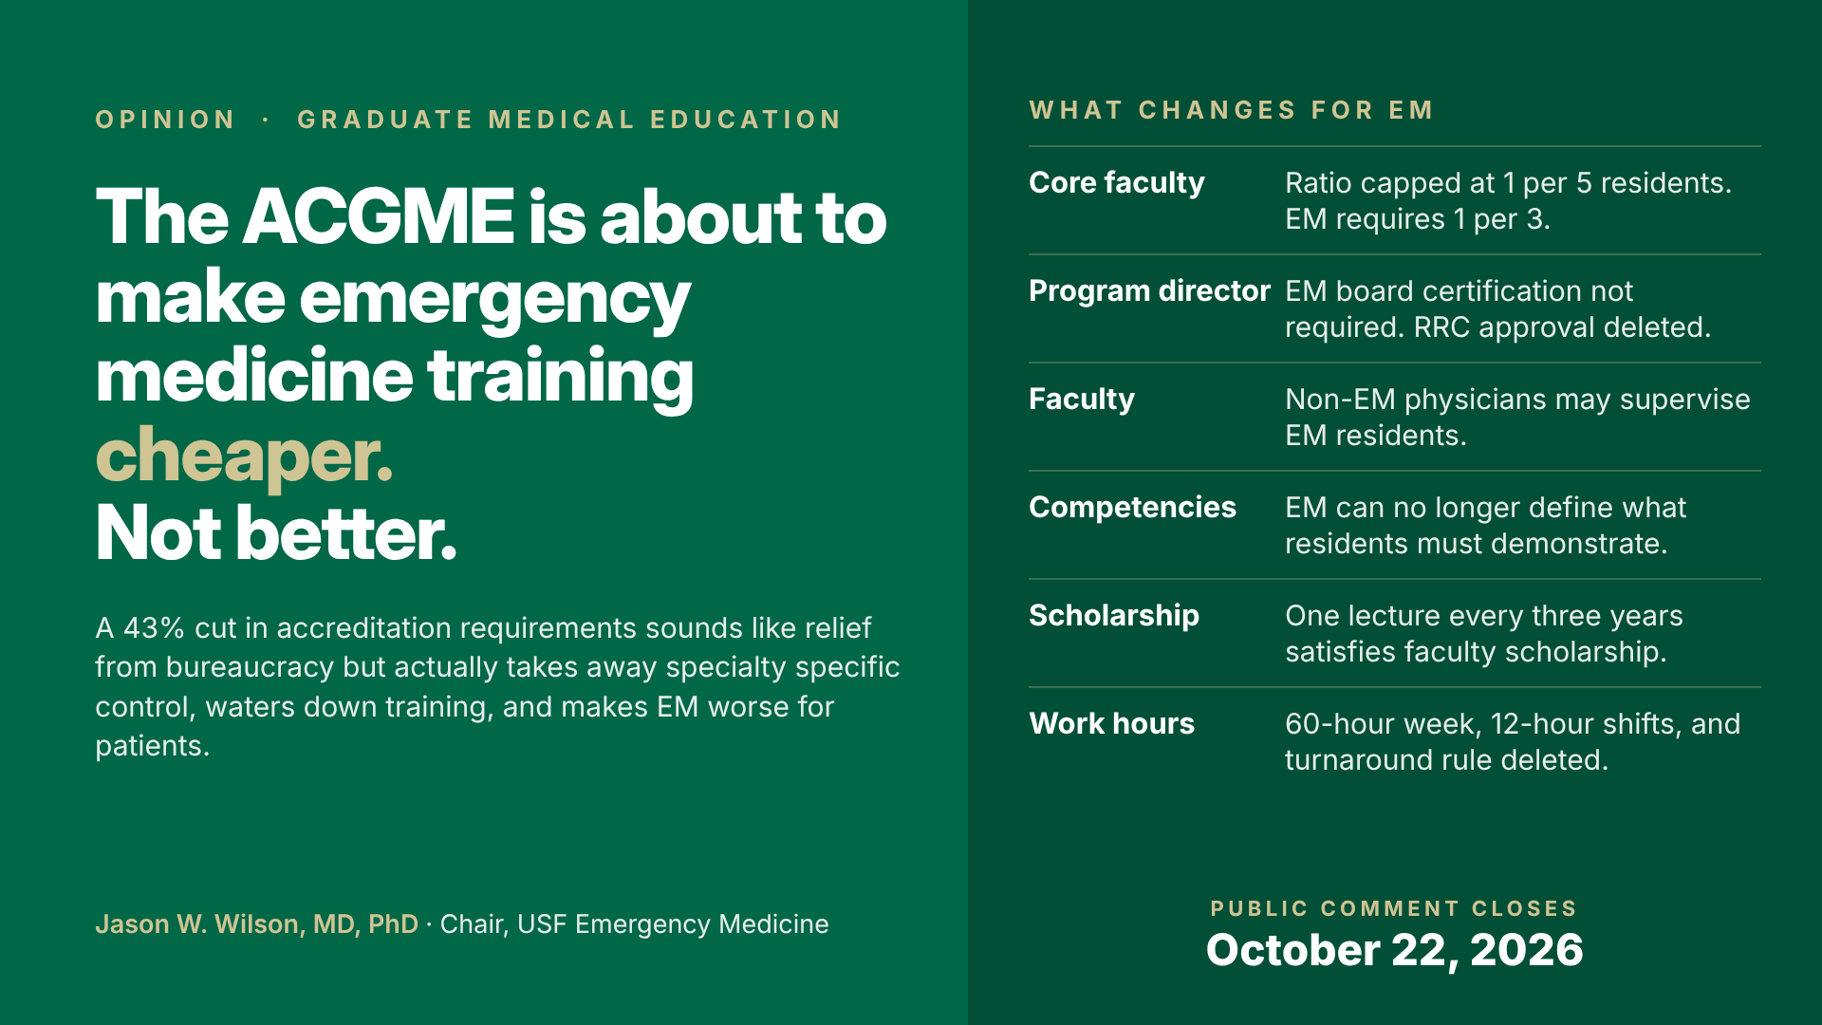
Fewer Rules, Weaker Residency Programs, Less Faculty Development: How the ACGME’s Proposed Common Program Requirements Make Emergency Medicine Worse
A 43 percent cut in accreditation requirements sounds like relief from bureaucracy. Read closely, it is a transfer of authority away from the specialties that know what a well-trained physician looks like, and it erodes the academic mission to advance the science of EM.
By Jason W. Wilson, MD, PhD • Professor and Founding Chair, Department of Emergency Medicine, USF Health Morsani College of Medicine; Chief of Emergency Medicine, Tampa General Hospital • October 8, 2026
On September 8, the ACGME posted a proposed major revision of the Common Program Requirements, the rules governing every residency, presented as a 43% reduction in requirements. If you train residents, supervise them, or are one, you have two weeks to comment (they close October 22). If you care about academic integrity and faculty development, this matters.
Since 2014, ACGME-accredited emergency medicine residencies have grown from 160 to 304, and 86 percent of new programs are at non-university corporate, private equity, or community sites. Those programs have fewer faculty, less protected time, less rank advancement, less funded research, less student teaching, and lower scholarly productivity, which limits new academic faculty and stunts the science. ACGME requirements set a program's minimums, including protected faculty time and scholarly activity.
The Proposal
It changes who decides what an emergency physician must be able to do, who may teach them, and how much effort goes to teaching. Common standards get broader, specialty-specific requirements are deleted, and the specialty Review Committees lose the authority to put them back. That waters down accreditation, widens the quality gap across sites, and moves EM away from an academic model.
Core Faculty
Emergency medicine requires one core faculty member per three residents. Core faculty positions are often a junior physician's first academic appointment, protected time that, with mentorship, produces papers, trials, and the next generation of teachers, and institutions fund only to the ACGME minimum. The proposal caps what any Review Committee may require at one per five, cutting my department's required core faculty from thirteen to eight. The stated reason, burden on small programs, is cost, not education.
Program Director
Today a director must be board certified, have three years of educational or administrative experience, and have Review Committee approval. The proposal swaps the three years for a mentoring plan, lets a GME committee approve a director not eligible for certification, and drops Review Committee approval. The program director is the specialty's most visible representative to young residents and should be a trained, experienced leader. A program that cannot field one should not exist.
Faculty
The same GMEC pathway opens for non-board-eligible faculty, and specialties are told supervision rules "should include flexibility" for other specialties' physicians. Emergency medicine residents in an emergency department should be supervised by emergency physicians. If other specialties need flexibility, let each decide.
Scholarship
EM faculty must now show accomplishment in three scholarly domains and disseminate it, including peer-reviewed publication. The proposed minimum is one activity every three years, and a lecture counts. The Review Committee may no longer require publication.
Patient Care
Competency requirements shift from what residents must demonstrate to what programs must teach, and Review Committee authority to specify content is deleted. Resident participation in quality and safety review should stay, because attendings everywhere serve on those committees.
The Environment This Lands In
EM training is already heterogeneous. Graduates may not leave with equal ability, and faculty whose support stops at the required FTE rarely become the academicians who advance the field.
Lowering the floor widens the variability. Well-resourced departments will keep 1:3, publication, and their director standards, because that is how academic departments grow people. State university programs may be held to the ACGME minimum by their funders, and corporate groups will welcome the savings. All of academia faces this cost-cutting approach to teaching, which grows neither faculty nor discipline. Lower cost and less regulation suit the corporate and private-equity employers behind this growth. The ACGME should be the counterweight protecting patients, trainees, and faculty.
Board Pass Rates
The 90 percent ultimate board certification standard is a real outcome requirement, though the new two-of-three first-time rule forgives a failed cohort, and a program not ready to train should not get that pass.
Work Hours
Removing EM's 60-hour week makes little functional difference, since residents already work closer to 45 hours, but the optics are poor in a specialty with rampant burnout, and deleting Review Committee authority to set a limit below 80 hours is the real problem.
The Role of the ACGME
First, ensure standards that produce highly trained physicians for our communities. Cutting regulation is cheaper for sponsoring institutions, not better for patients. Second, set the floor, but let each specialty adapt requirements to its field through its Review Committee. Third, recognize growing corporate influence on graduate medical education and balance it. Accreditation exists to protect residents' training, which requires qualified educators and an ACGME mindful of academic medicine's future. This proposal creates inequities in training and calls them flexibility.
Action Step
The comment form is at acgme.org under Review and Comment, Common Program Requirements (Residency). I am asking every faculty member and resident to submit comments.
To view my responses and suggested considerations for your own response, please go to tampaerdoc.github.io/acgme-cpr-response.
Jason W. Wilson, MD, PhD, CPE, CPHQ, FACEP, is Professor and Founding Chair of the Department of Emergency Medicine at the University of South Florida Morsani College of Medicine, Chief of Emergency Medicine at Tampa General Hospital, and Vice President and Academic Co-Chief of the TGH Emergency Services Institute. He is board certified in Emergency Medicine and Addiction Medicine and holds an affiliate appointment in the USF Department of Anthropology. The views expressed are his own.
Sources: ACGME, Proposed Major Revision of the Common Program Requirements (Residency), tracked-changes copy, Sept. 8, 2026. ACGME, Rationale and Impact Statement, Sept. 8, 2026. CORD, “Proposed ACGME Common Program Requirement Changes: What Could They Mean for Emergency Medicine?”, Oct. 2026. Program growth figures from the USF EM Faculty Census, Sept. 2026.

